Problem Statement:
Create a static website. Host it on a S3 bucket and access it from CloudFront.
Steps to follow:
- Create a bucket by the Domain name
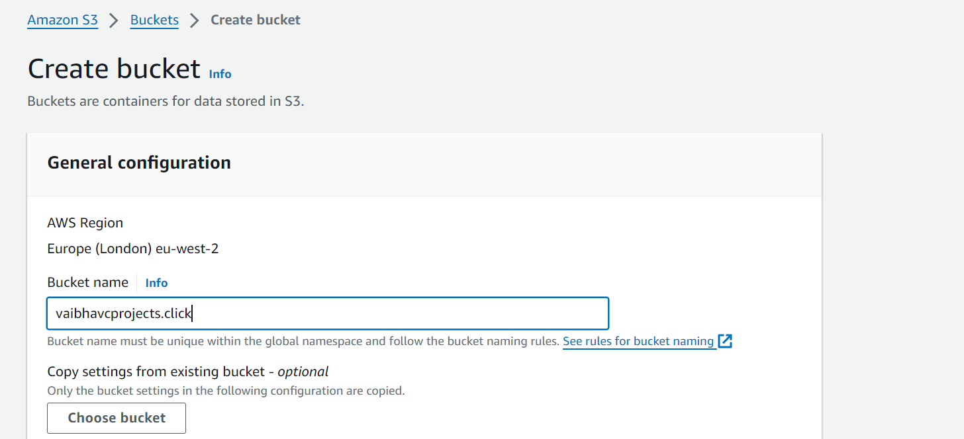

- Click the checkbox Block all public access so that only Cloudfront must be able to access the Bucket and users should not be able to go the Bucket directly
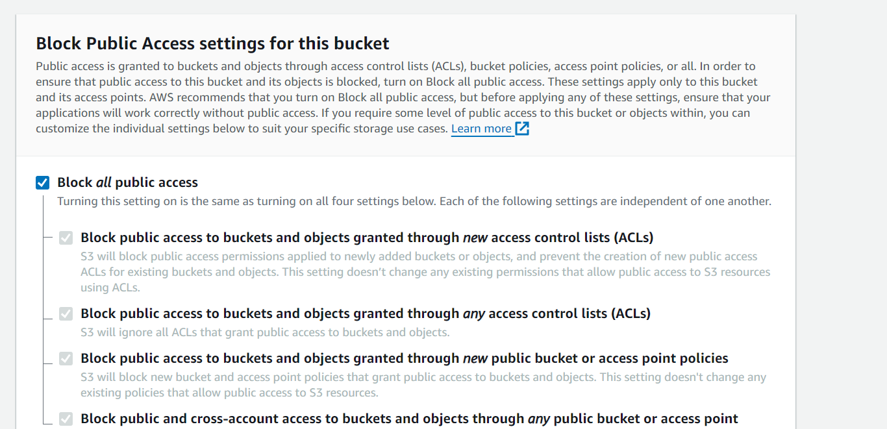

- Enable Bucket versioning
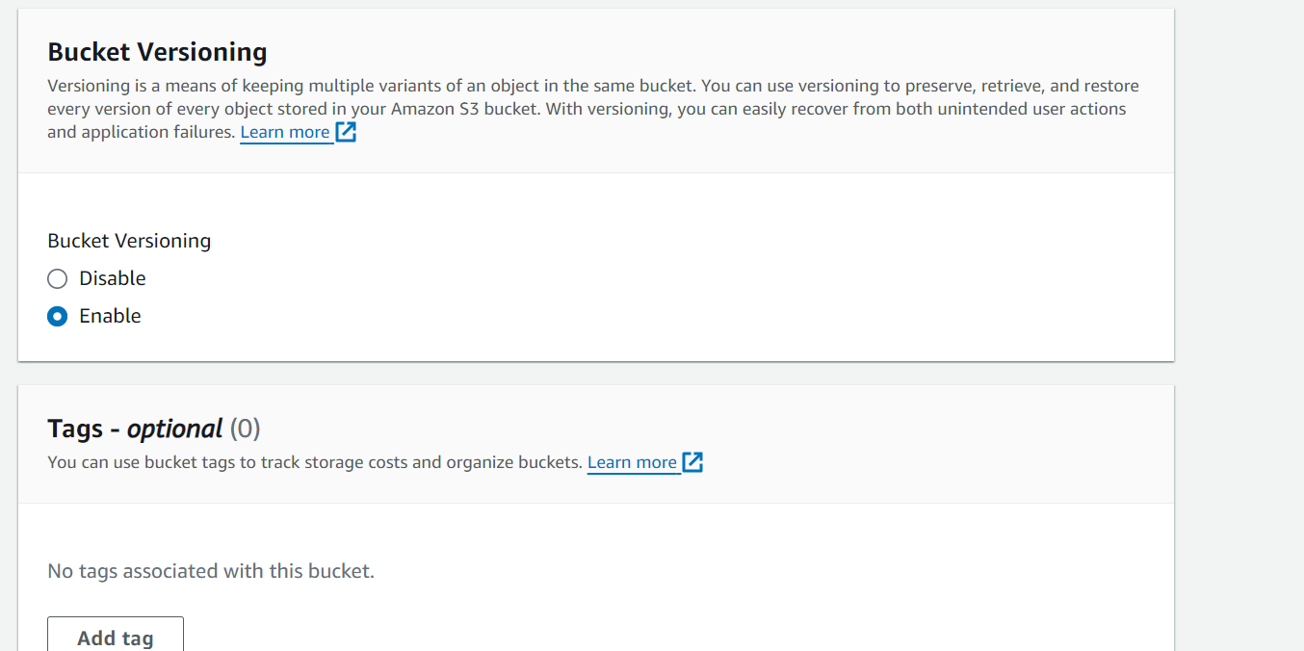

- Keep default settings for rest of the configurations and click ‘Create Bucket’
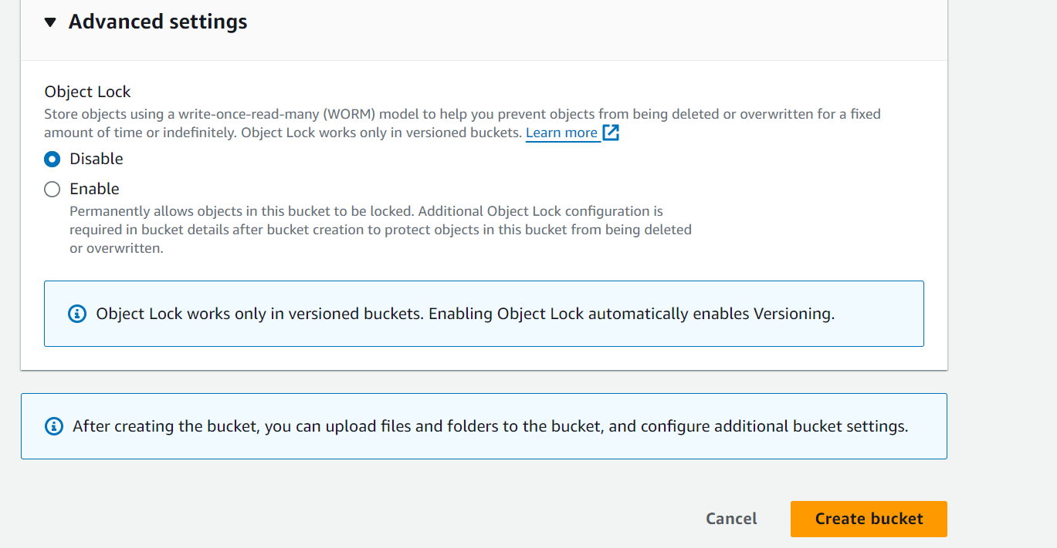

- A bucket has been created
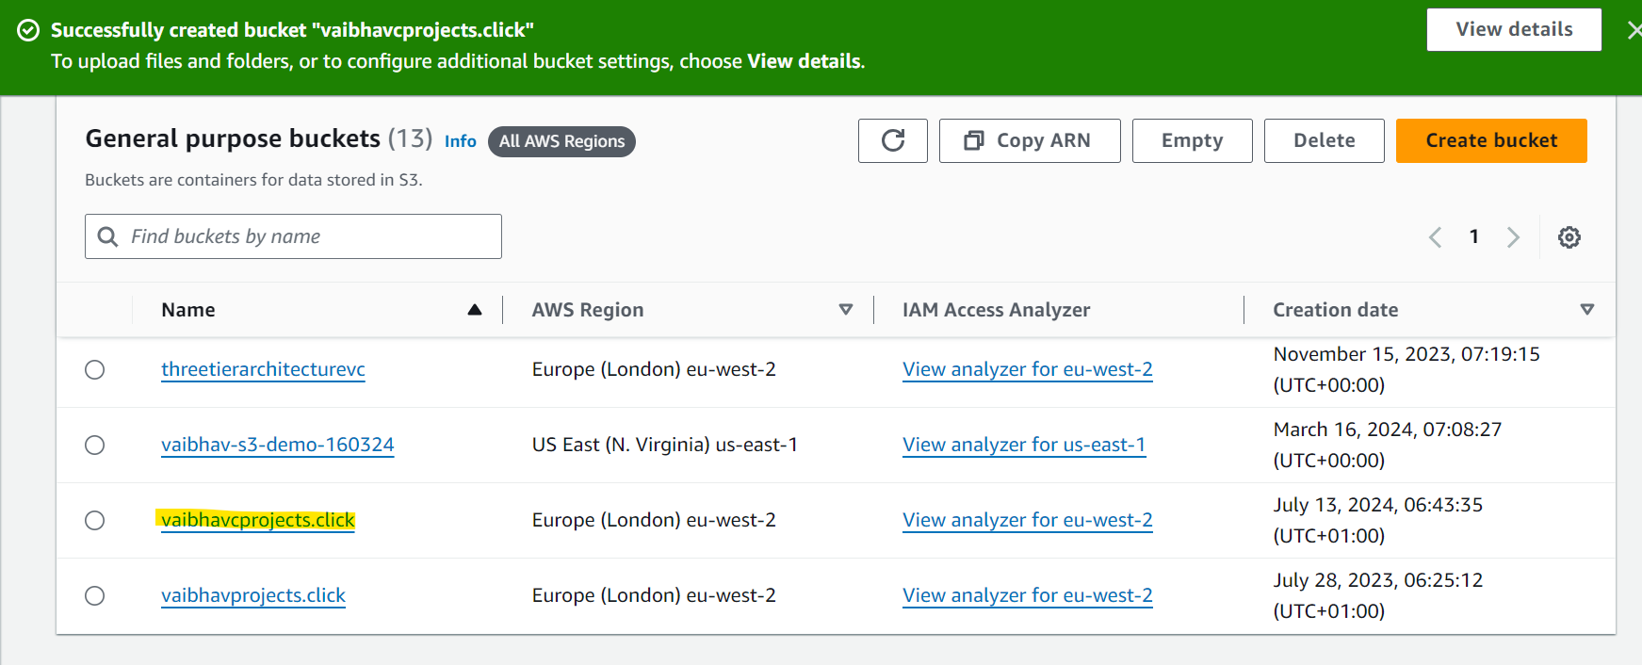
- Go to the bucket and click Properties
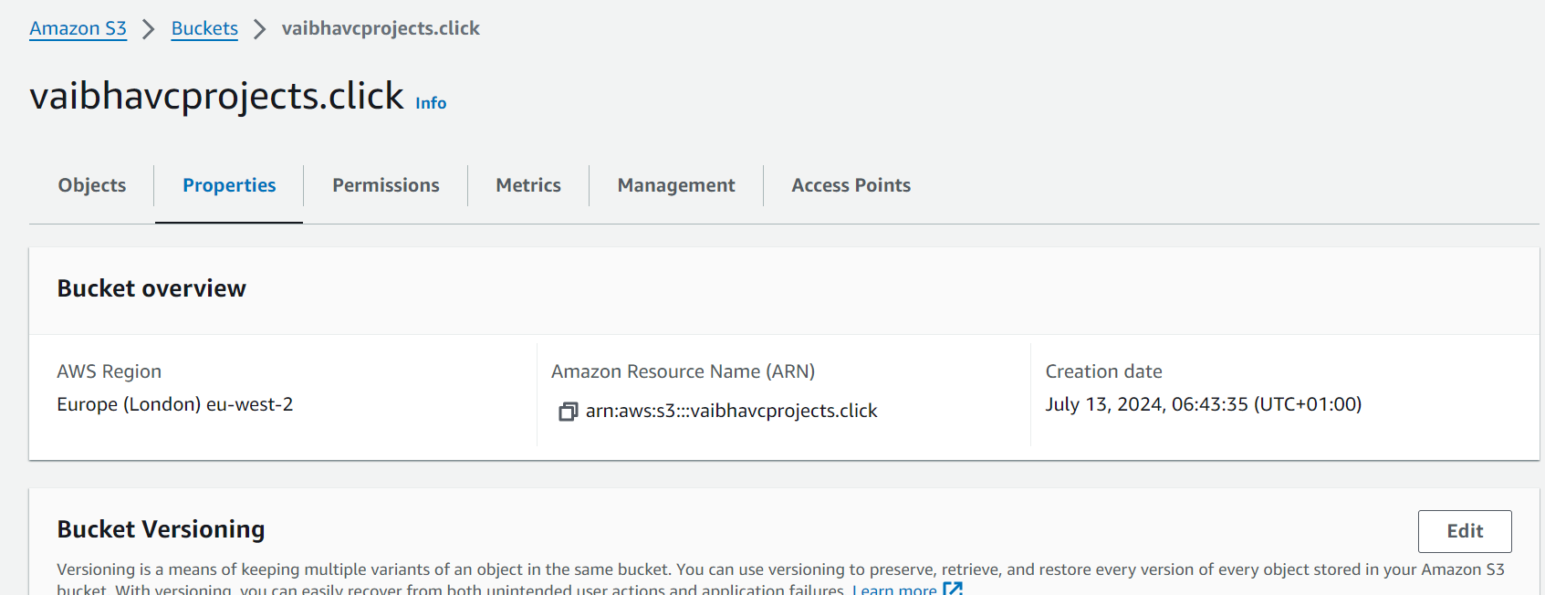

- Scroll down and enable Static website hosting
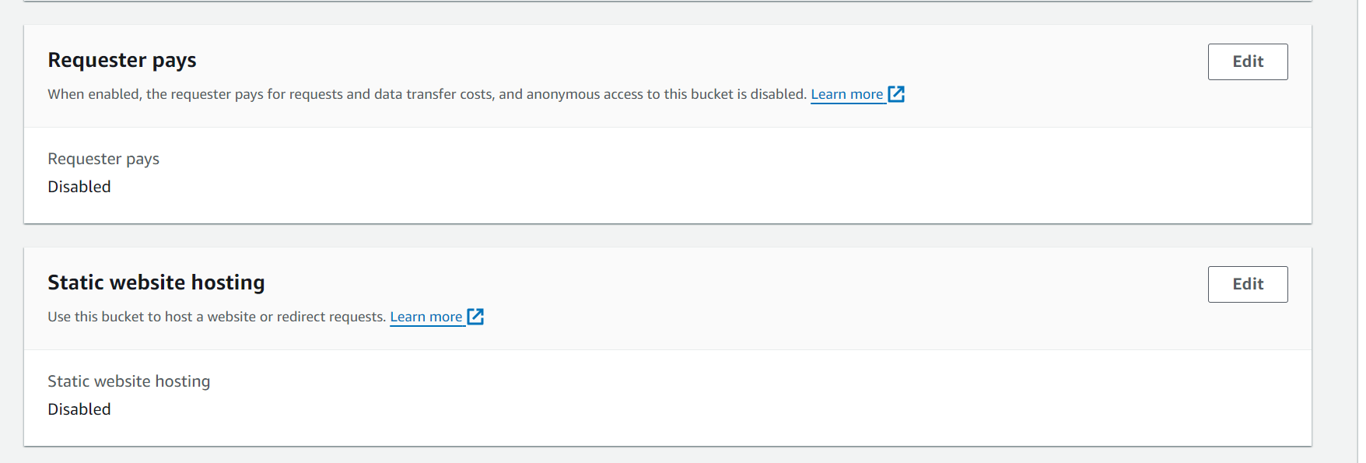

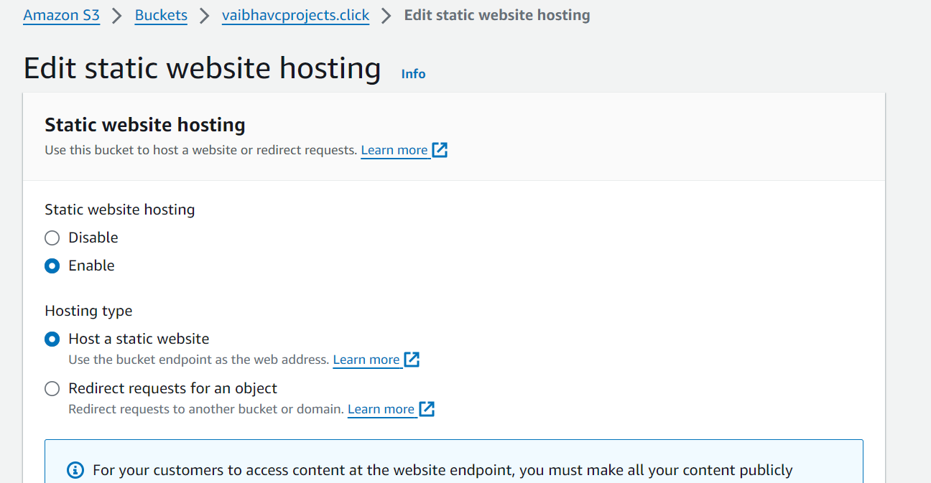

- Add Index document and Error document as shown and click Save Changes
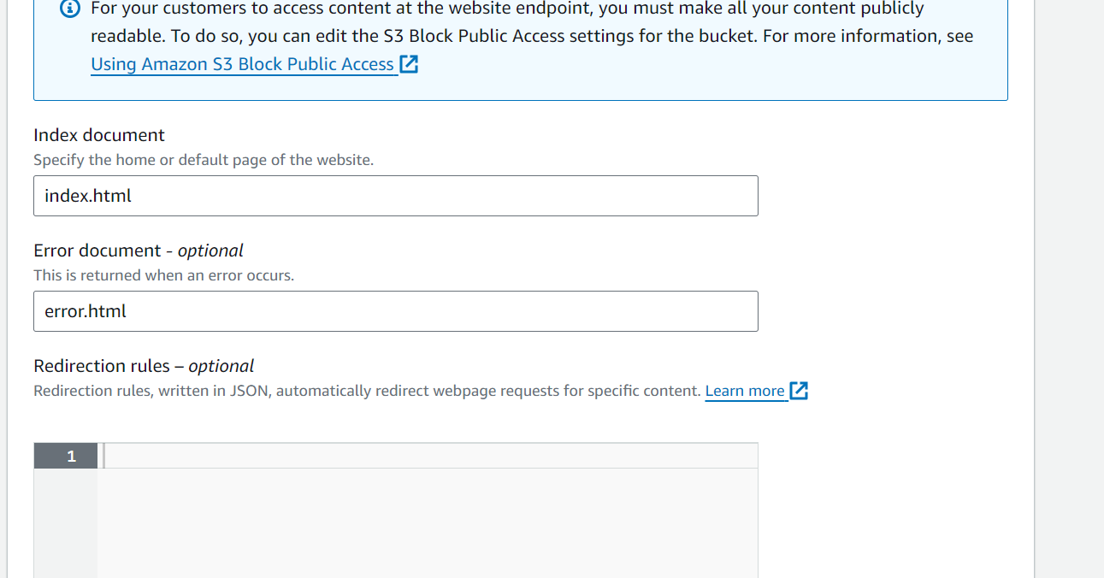

- Go to the bucket and upload the files
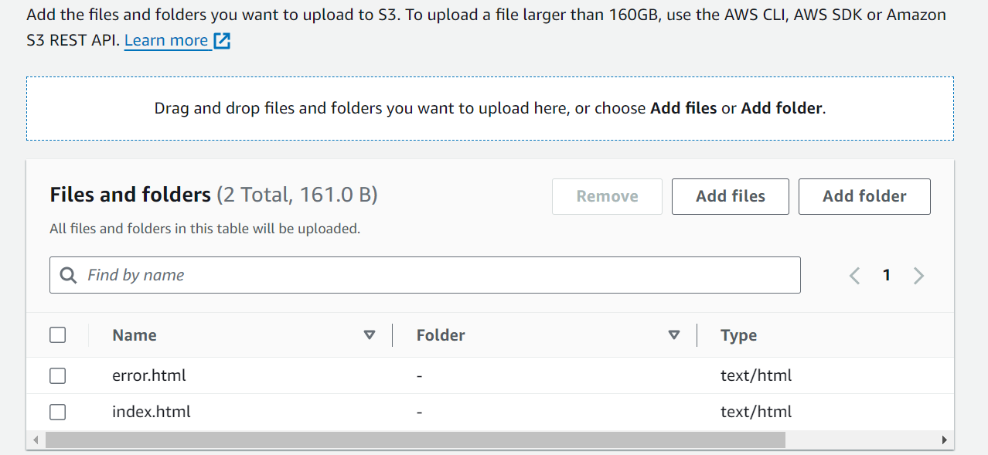

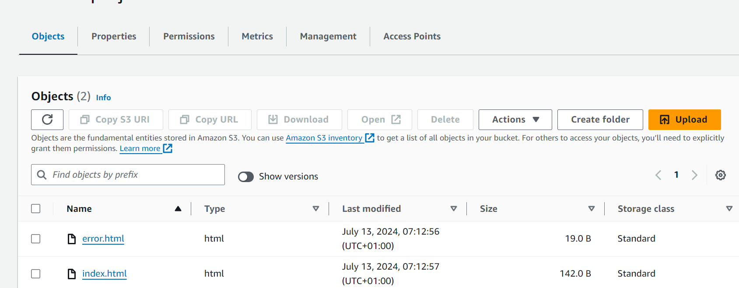

7. Go to properties of the bucket and copy URL for static website hosting

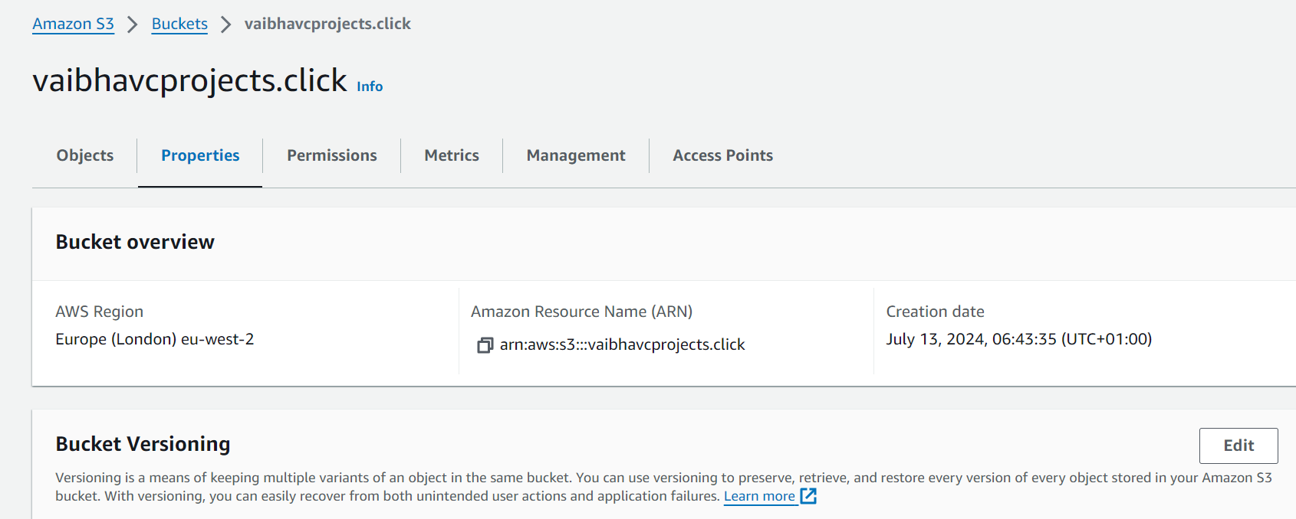
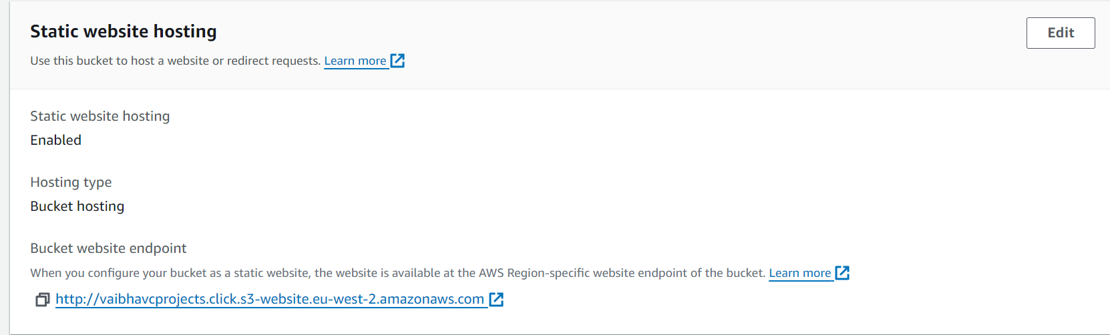

8. Access the URL and you should not be able to access it because the public access has been blocked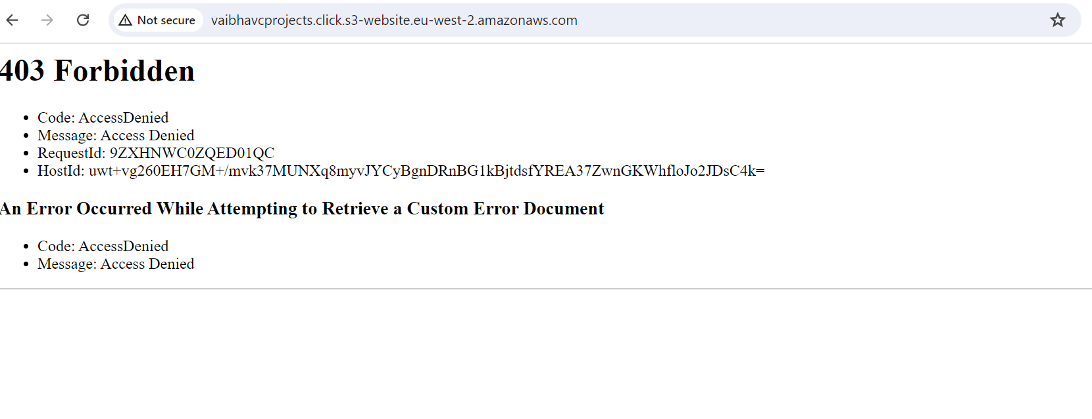
9. To host this URL ,Go to CloudFront and click on Create distribution. Choose Origin domain as the bucket which was created. Origin domain is the source from where the website will be served. Ignore the warning message ‘Use website endpoint’ as it is not relevant

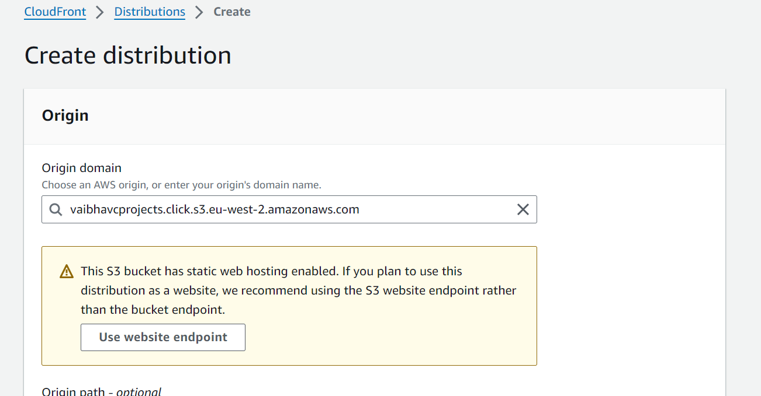

- Name of the Origin will be auto populated. Select Legacy access identities and create origin access identity. Click on ‘Yes update the bucket policy’. This is to ensure that the identity related to Cloudfront will have access to the bucket.

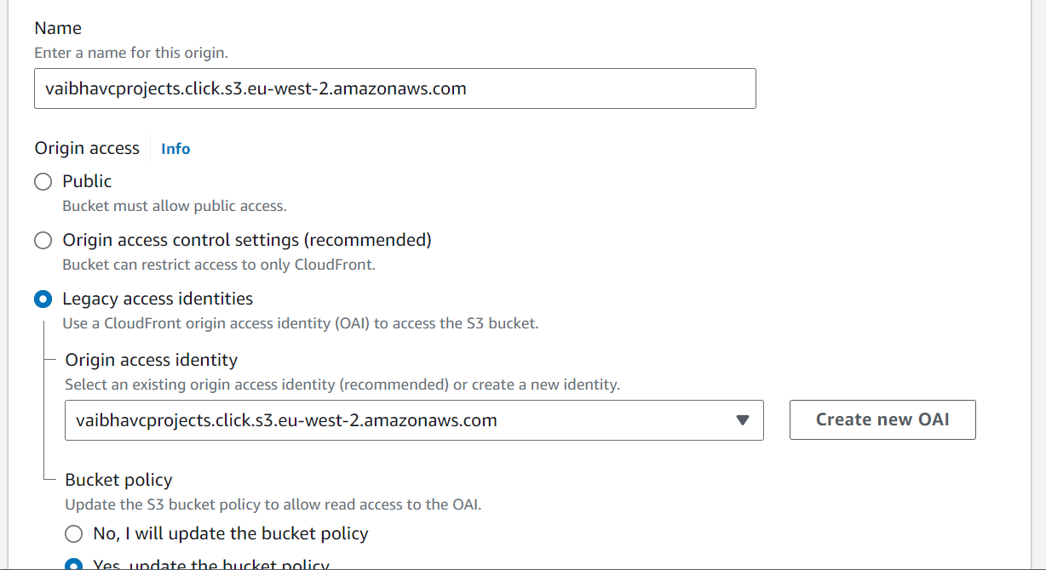

- Use all edge locations for best performance. This setting should be enabled if users from all over the world are expected to visit your website and you want to cache the content across all the edge locations.
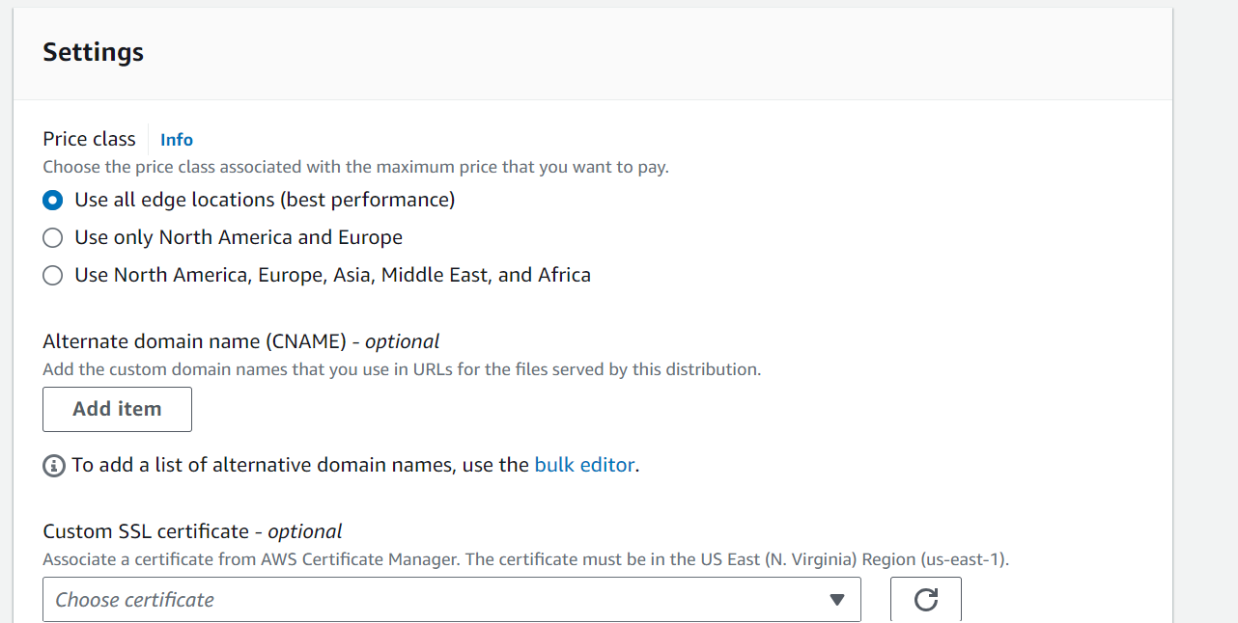

- Do not enable Web Application Firewall
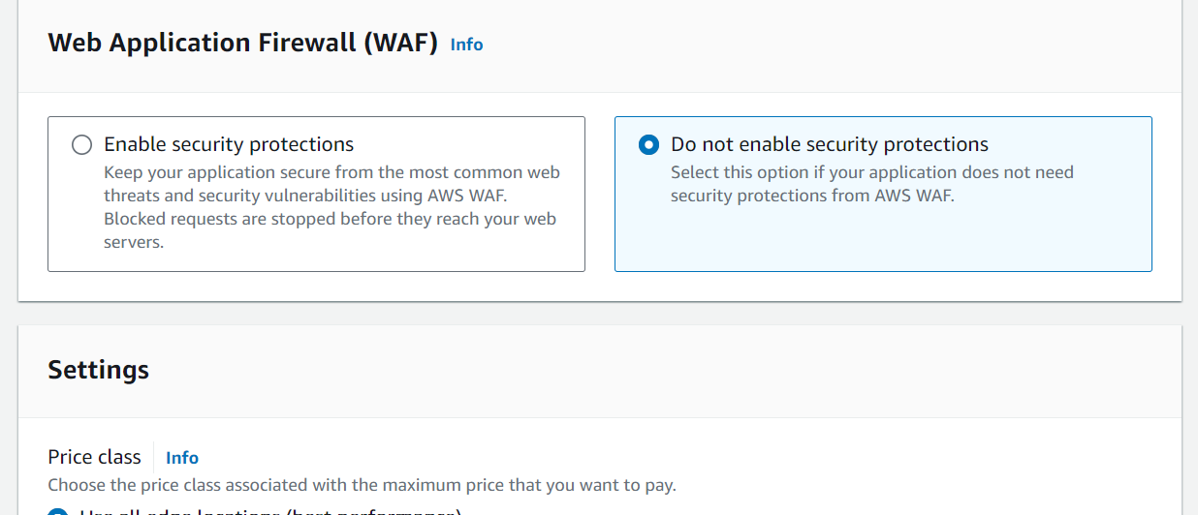
- Add Default root object as index.html. If the S3 bucket contains multiple objects and user goes to the root URL instead of a specific object then this configuration will serve the default root object. Keep rest of the settings as default and click Create distribution
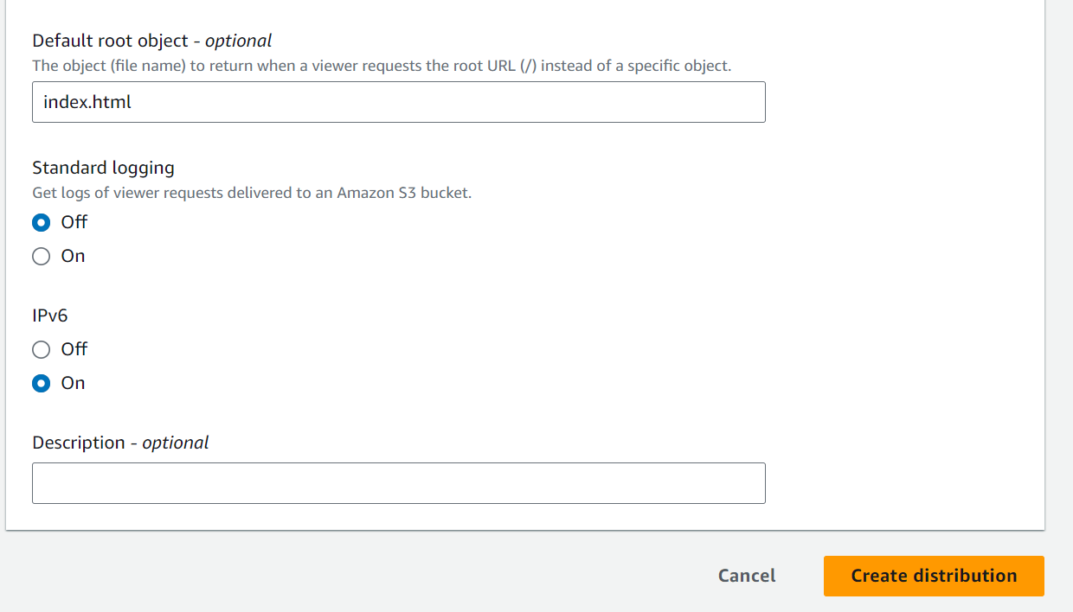

- A distribution will be created
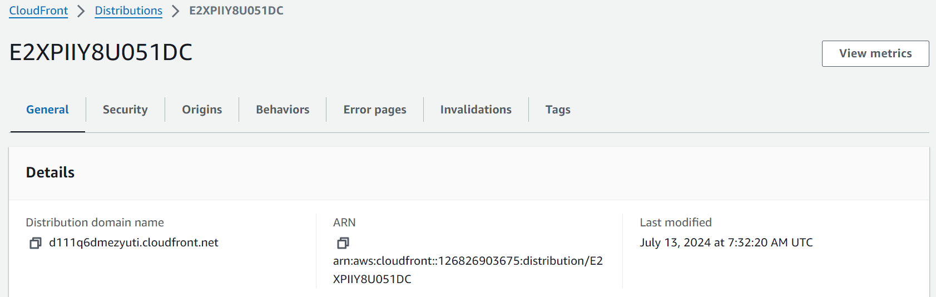

- Copy the Distribution domain name and open it in a browser. You can see that the website is accessible.
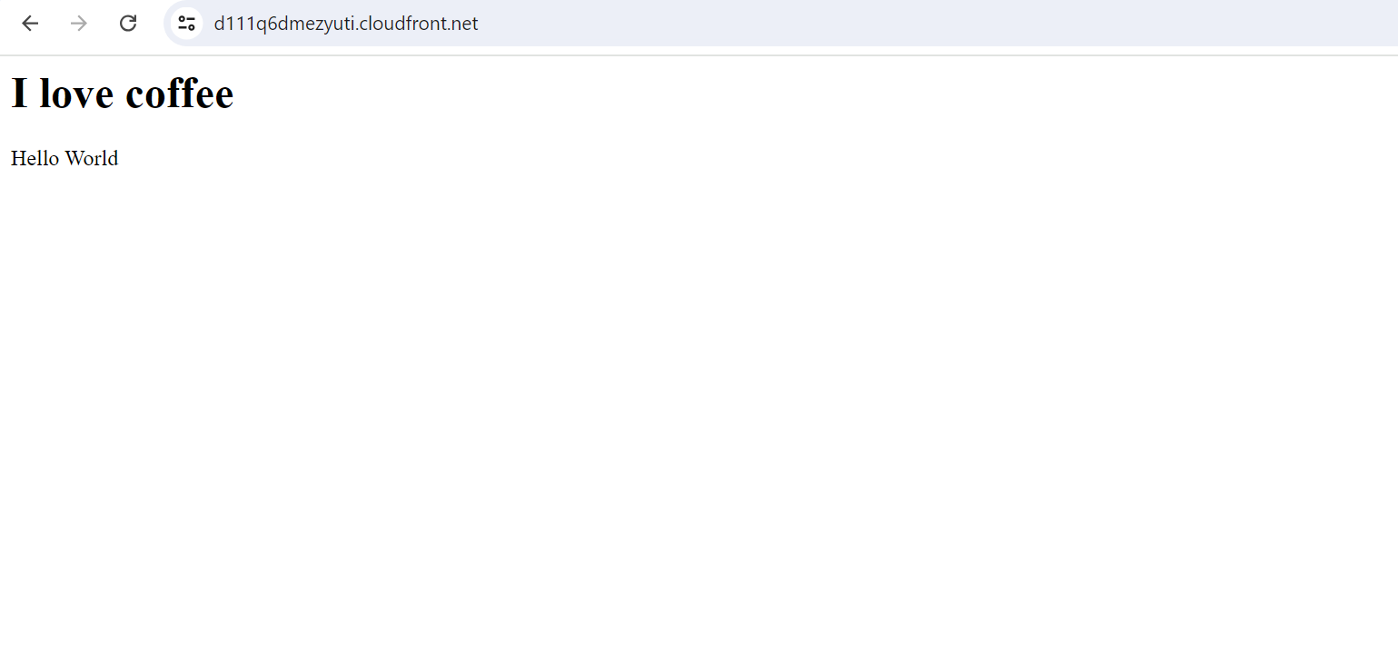

- Go to S3 Bucket and check Permissions. The Bucket policy has been updated automatically. You can see that a principal related to Origin Access Identity has been added. This policy allows the OAI to access the bucket and get the objects uploaded on the bucket
